Lab #4: Newtons Law

Names: Cade Rosenlund, Ryan Levanen, Alex Sanders, Ethan Alliot, Luis Matata

Objective: To confirm that a given force changes the acceleration with the mass of the object.

Experiment #1:

Given F is constant, use variable mass to determine the change in acceleration.

Experiment #2:

Given the mass of the cart is the same, and the mass is changing determine the acceleration of the cart.

Data:

Experiment 1:

|  |  |  |  |  |
| --- | --- | --- | --- | --- |
| Weight Added g | 50 | 100 | 150 | 200 |
| Run 1 | 0.9695 | 0.7777 | 0.6065 | 0.5287 |
| Run 2 | 0.9351 | 0.6836 | 0.6418 | 0.5443 |
| Run 3 | 0.9639 | 0.7793 | 0.6432 | 0.5469 |
| Run 4 | 0.9763 | 0.7794 | 0.6261 | 0.5117 |
| Run 5 | 0.9612 | 0.7778 | 0.6419 | 0.5462 |
| Mean | 0.9612 | 0.75956 | 0.6319 | 0.53556 |
| S.D. | 0.015695541 | 0.042470496 | 0.015846924 | 0.015285222 |
| Force | 323.9244 | 293.94972 | 276.1403 | 260.81772 |
| Mass of Cart | 337 | 387 | 437 | 487 |
| 1/M | 0.002967359 | 0.002583979 | 0.00228833 | 0.002053388 |

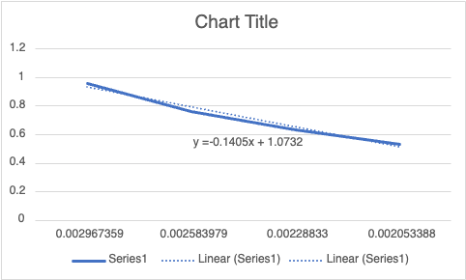

Experiment 2:

|  |  |  |  |  |
| --- | --- | --- | --- | --- |
| m=387g | 50g | 100g | 150g | 200g |
| Run 1 | 0.7737 | 1.44 | 2.009 | 2.42 |
| Run 2 | 0.7775 | 1.449 | 2.009 | 2.455 |
| Run 3 | 0.7807 | 1.437 | 2.026 | 2.464 |
| Run 4 | 0.777 | 1.441 | 2.002 | 2.477 |
| Run 5 | 0.7794 | 1.45 | 1.977 | 2.469 |
| Mean | 0.77766 | 1.4434 | 2.0046 | 2.457 |
| S.D. | 0.002665145 | 0.005770615 | 0.017784825 | 0.022169799 |
| Force | 300.95442 | 558.5958 | 775.7802 | 950.859 |

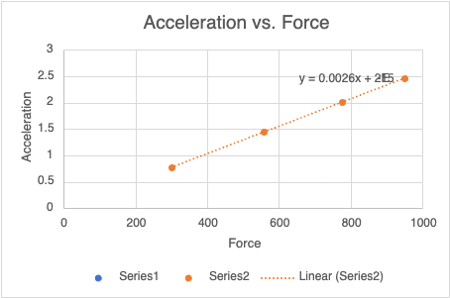

Analysis:

1. Did you notice an impact of friction? If so, what was the impact friction in the experiments?

No we did not notice an effect of friction. It would have skewed the data a little bit changing the acceleration values.   
2. Graph the results from activity 1 as acceleration vs. 1/M. (using excel)  
 a. Fit the graph with a straight line that passes through the origin. The plot should be  
 linear with a slope F. Is it linear?

The slope is linear with an F value of -.1405  
 b. What value of F do you obtain from the fitted line?

F = -.1405

3. Graph the results from activity 2 as acceleration vs. F. (using excel)  
 a. Fit the graph with a straight line that passes through the origin. The plot should be  
 linear with a slope of 1/M. Is it linear?

The slope is linear across our data points. M is equal to .0026. The value of 1/M is 0.002584, so rounded we get the same numbers.

b. What value of M do you obtain from the fitted line?

M = .0026

4. Assuming the cart is perfectly level and frictionless, that the pulley is massless and  
 frictionless, and that the string is massless, perfectly flexible, and not stretchable, obtain a  
 symbolic expression for the acceleration a of the cart in terms of cart mass M, hanging  
 weight mass m, and gravitational acceleration g. Include a FBD of the mass m.



A = F/m



5. From the symbolic expression you obtained in question 4, would you expect a perfectly  
 straight line in a vs 1/M and a vs. F plots? What approximation(s) is (are) implicit in claiming  
 the plots “should” be linear?

Yes, because it’s all linear with relation to the variables themselves.  
6. How could the experiments be conducted to make the plots theoretically linear, or at least  
 for their deviations from linearity to be undetectable?

If there was no friction at all then the acceleration would be perfect.

Conclusion:

In this lab we concluded that the changing of the pulling mass and changing the cart mass affects the acceleration proportionally.